EXPERIMENT 4A – DATA INSPECTION, FILTERING, STATISTICAL ANALYSIS AND CORRELATION

Aim
To perform data inspection, filtering, sorting, statistical analysis, visualization, grouping, and correlation analysis on a student dataset using Pandas, NumPy, and Matplotlib.

Algorithm
Step 1: Import the required libraries such as Pandas, NumPy, and Matplotlib.
Step 2: Load the student dataset from the CSV file using pd.read_csv().
Step 3: Display the first five records of the dataset using df.head().
Step 4: Determine the number of rows and columns using df.shape.
Step 5: Display the data types of all columns using df.dtypes.
Step 6: Inspect the complete structure of the dataset using df.info().
Step 7: Filter students who scored more than 85 marks.
Step 8: Filter students belonging to the IT department.
Step 9: Sort the dataset based on marks in descending order using sort_values().
Step 10: Visualize the student marks ranking using a bar chart.
Step 11: Calculate the mean, median, mode, and standard deviation of student marks.
Step 12: Generate descriptive statistical measures using df.describe().
Step 13: Group the students based on their department and calculate the average marks for each department.
Step 14: Visualize the department-wise average marks using a bar chart.
Step 15: Select the numerical columns, Marks and Attendance, and calculate their correlation matrix using corr().
Step 16: Create a scatter plot between Attendance and Marks to visualize their relationship.
Step 17: Display all the generated results and visualizations.
Program:
import pandas as pd
import numpy as np
import matplotlib.pyplot as plt

# Load the student dataset
df = pd.read_csv(r"C:\Users\palan\OneDrive\Documents\student.csv")

# Display the dataset
print(df)

# Display first five records
print(df.head())

# Display data types
print(df.dtypes)

# Display shape of dataset
print("Shape of Dataset:")
print(df.shape)

# Display dataset information
df.info()

# Filter students with marks greater than 85
high_marks = df[df["Marks"] > 85]

print("Students with Marks Greater than 85:")
print(high_marks)

# Filter IT department students
it_students = df[df["Department"] == "IT"]

print("IT Department Students:")
print(it_students)

# Sort students based on marks in descending order
sorted_df = df.sort_values(
by="Marks",
ascending=False
)

print("Students Sorted by Marks:")
print(sorted_df)

# Bar chart for student marks ranking
plt.figure(figsize=(8, 5))

plt.bar(
sorted_df["Name"],
sorted_df["Marks"]
)

plt.xlabel("Students")
plt.ylabel("Marks")
plt.title("Student Marks Ranking")

plt.show()

# Calculate statistical measures
print("Mean =", df["Marks"].mean())

print("Median =", df["Marks"].median())

print("Mode =")
print(df["Marks"].mode())

print("Standard Deviation =", df["Marks"].std())

# Display descriptive statistics
print(df.describe())

# Calculate department-wise average marks
dept_avg = df.groupby(
"Department"
)["Marks"].mean()

print("Department-wise Average Marks:")
print(dept_avg)

# Plot department-wise average marks
plt.figure(figsize=(7, 5))

dept_avg.plot(
kind="bar"
)

plt.xlabel("Department")
plt.ylabel("Average Marks")
plt.title("Department-wise Average Marks")

plt.show()

# Calculate correlation between Marks and Attendance
corr = df[
["Marks", "Attendance"]
].corr()

print("Correlation Matrix:")
print(corr)

# Scatter plot of Attendance vs Marks
plt.figure(figsize=(7, 5))

plt.scatter(
df["Attendance"],
df["Marks"]
)

plt.xlabel("Attendance")
plt.ylabel("Marks")

plt.title("Marks vs Attendance Relationship")

plt.show()

Output:
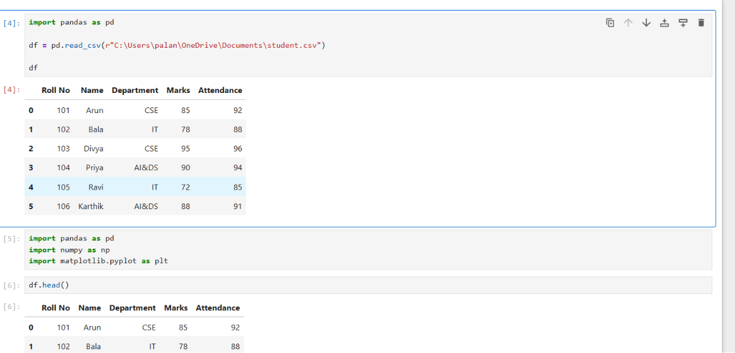

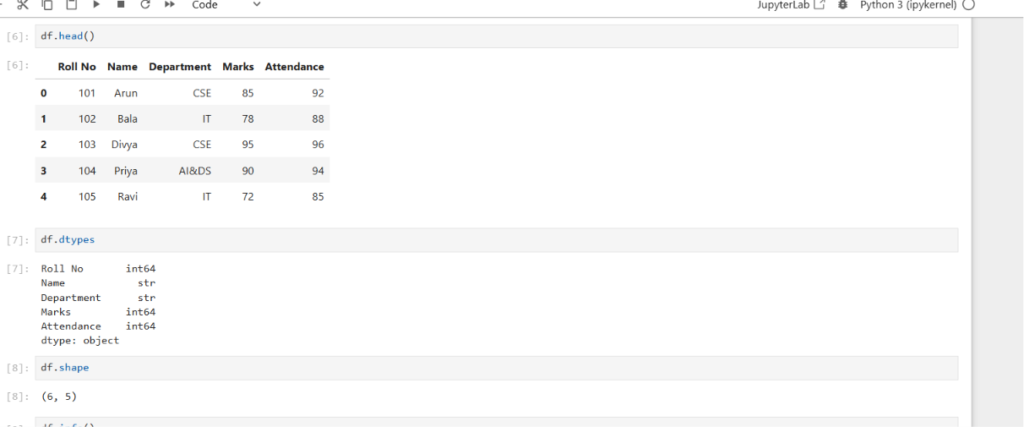
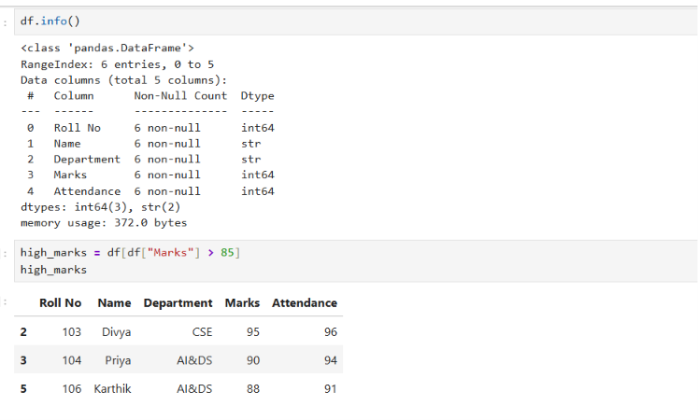
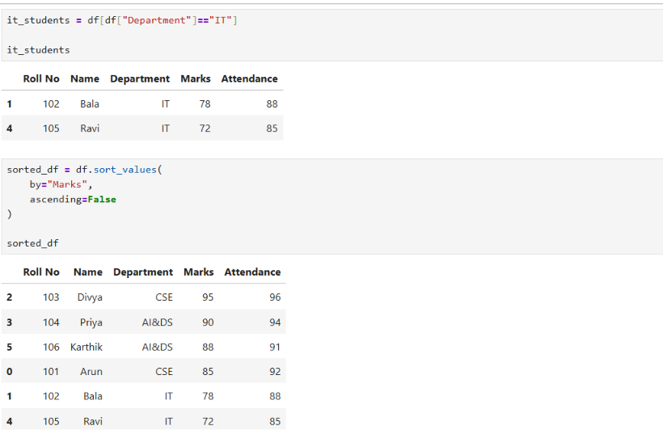
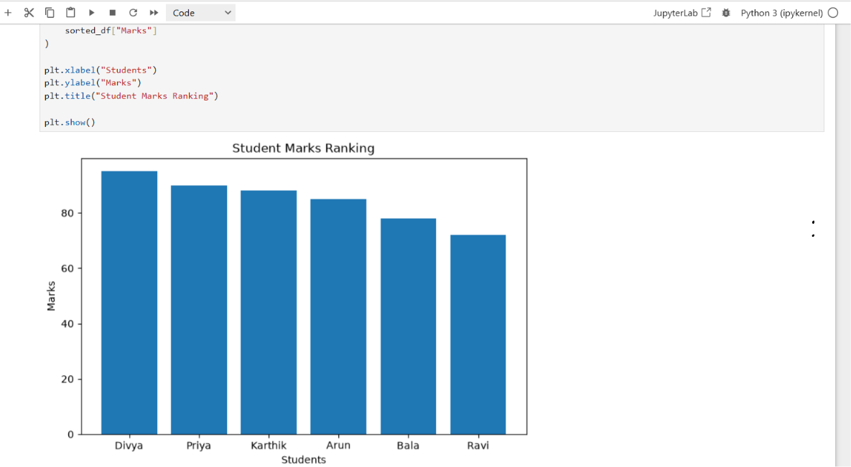
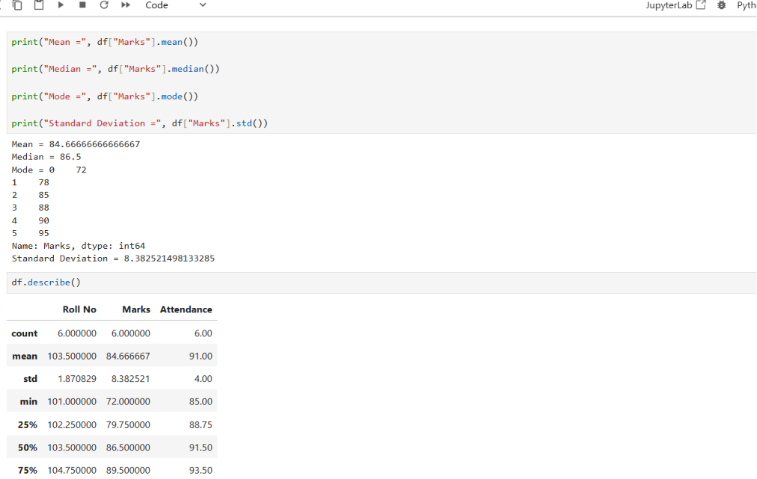
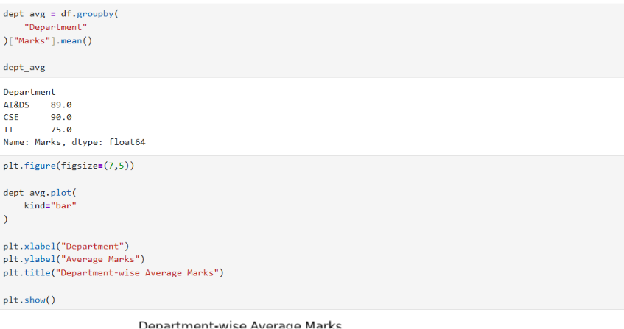
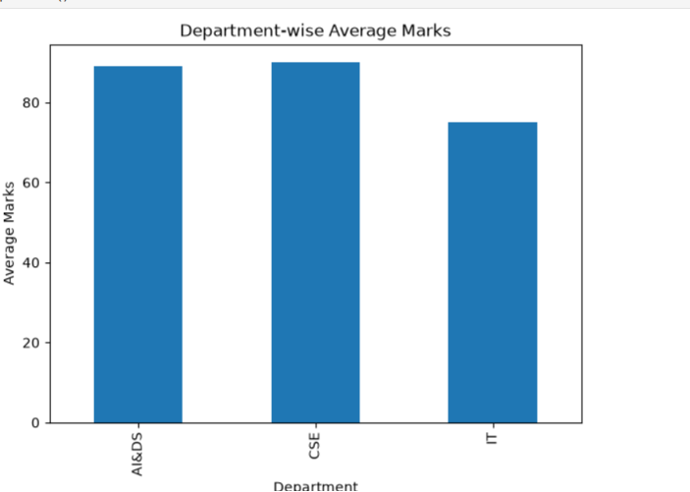
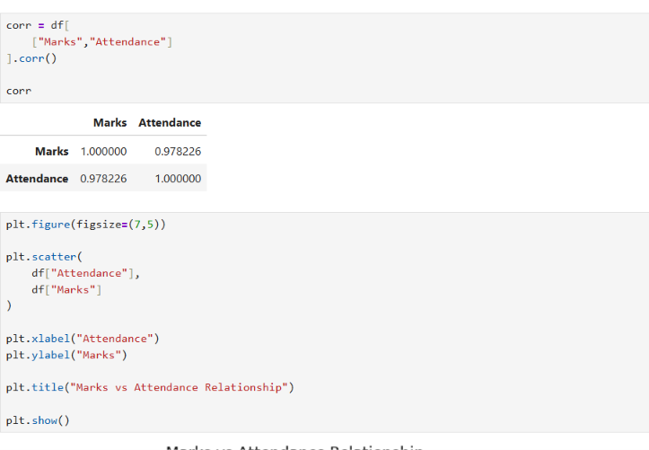
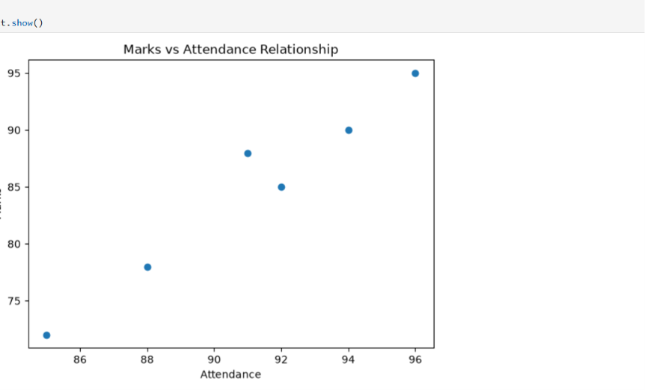

Result
Thus, the student dataset was successfully inspected, filtered, sorted, statistically analyzed, grouped, visualized, and correlated using Python. The analysis identified students with high marks, filtered students based on their department, calculated important statistical measures, compared average marks across departments, and examined the strong relationship between student attendance and marks.

